**Architecture**

**Introduction**

**TWITTER DATA ANALYSIS**

Twitter is a social media platform on which people interact with each other through “tweets”. These tweets can be used for performing different analytical queries and to develop interesting visualizations.

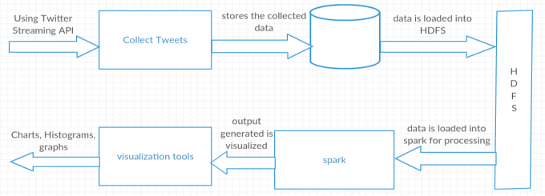

* Collecting tweets from twitter.
* Collecting hashtags and URLs using hadoop.
* Analysing the tweets using spark.

**Methods**

**VISUALIZATIONS**

**Popular Technologies**

**Popular languages**

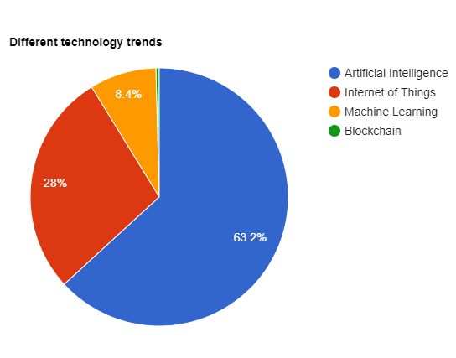 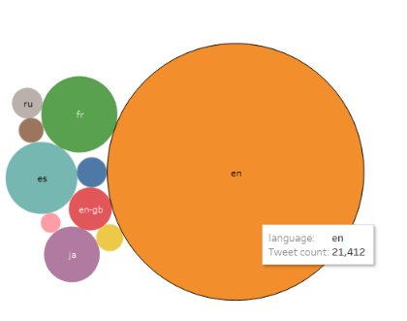

**Different U.S States trend**

**Monthly tweets on technology**

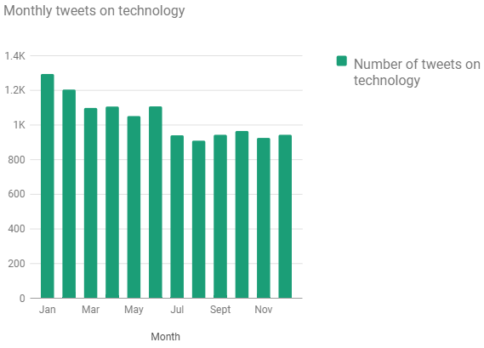 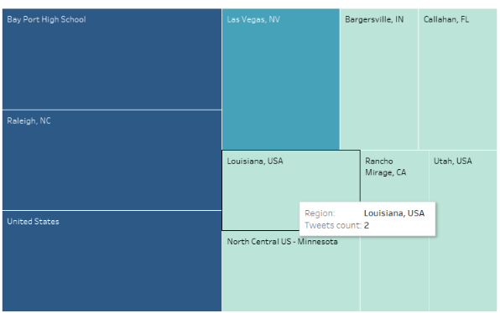

**Popular companies trend on technology**

**Technology languages trend**

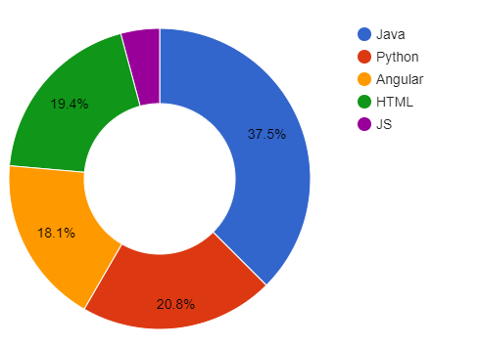 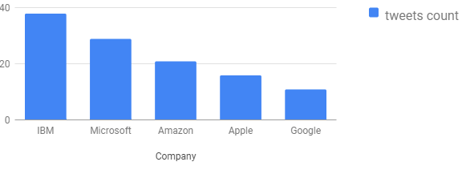

**Users with more friends and followers count**

**Day wise tweets on technology**

**Users who got most re-tweet**

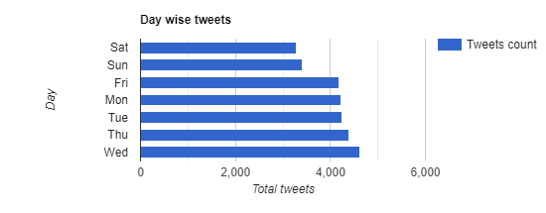 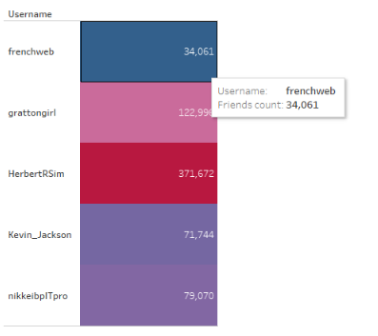 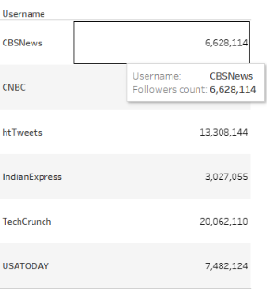

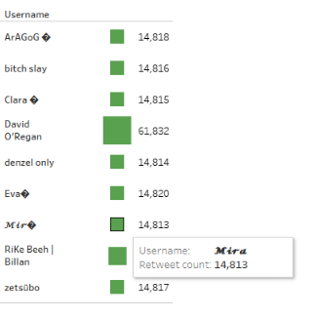      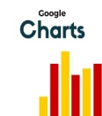

**Sindhusha Tiyyagura, Pradeepika Kolluru, Thoshita Movva**

**Technologies Used**